Objectives:
It’s About Authenticity!
KSS 2019 with Kyle Markwalter
markwaltermath.weebly.com
kyle.markwalter@kippsanjose.org
Teachers Wil Be Able to:
- Discuss three different effective strategies for investing students in the ACT IA process within a classroom.
- Identify ways to deemphasize the test-prep focus in a math classroom.
- Practice strategies for providing students with a truly college-preparatory math classroom that focuses on the primary course standards (CCSS, AP, or similar).

Keys to Investment
Notes:
Three Investment Suggestions
1. From early in the year, help students understand the purpose of the ACT IAs.
2. Design your class so that the CCRS are just part of what you do, not an extra thing that happens once a week.
3. Find the least intrusive way to keep you students invested.
Least Intrusive | Mildly Intrusive | Most Intrusive

Practice: Identifying Investment Strategies
Test-Prep Pitfalls
Pitfall 1: Direct modeling off of questions students will see on an IA.
ACT Question:
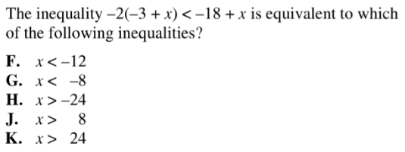
Similar Thinking Question Example:
Write three different inequalities that are all equivalent to x>4. Each inequality you write must require the distributive property to solve algebraically.

Writing Space:

Pitfall 3: Practice tests or quizzes that look like the test students will take.
Similar to Pitfall #1 but not just for IAs and ACTs. You can use the above solutions or the ones we will practice in the next section.

Pitfall 2: Overemphasizing correct answers on multiple choice problems.
ACT Question:
Break Down Incorrect Answers Examples:
In the above problem, what mistake would a student make that would result in choosing answer choice F?

Practice: Identifying Your Current Pitfalls
My current pitfall is:

My personal goal is:

Best practices and ideas for avoiding pitfalls:

Key Takeaways
Notes:

Making a Teaching Moment Truly College-Prep
Planning for Critical Thinking: Designing a rigorous multiple choice problem
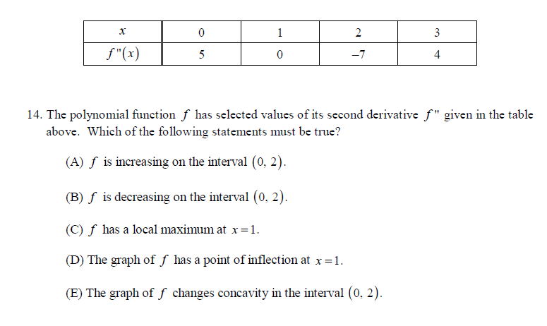

Rewriting for CCRS Alignment: Using an ACT Question Stem
Study up on the ACT question stems and vocabulary and repeat that with other questions.
KIPP Share has a Question Stems Chart, but it is almost TOO specific. I prefer more general stems.
Example 1: “Which of the following mathematical expressions is equivalent to…”
Can be followed by: 3x(x+1)-2x OR “A number, x, divided by 2 times the quantity 7x,” etc.

Example 2: As part of a lesson on motion, students observed a ___ rolling at a constant rate along a straight line. As shown in the chart below…
Can be followed by: any chart that students must work with.
Planning for Critical Thinking: Writing a Problem Backwards
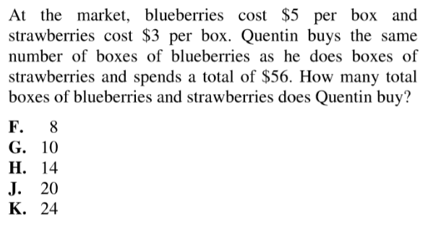
Backwards version:
Luis bought blueberries and strawberries for a total of 14 boxes altogether. He bought the same number of boxes of blueberries and strawberries. The blueberries cost $5 per box. Luis spent $56 total. How much is one box of strawberries?

Rewriting for CCRS Alignment: Rewriting a Multiple Choice Question for Authentic Discussion
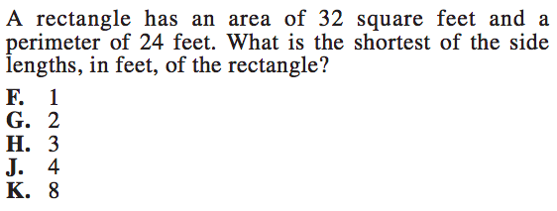
For authentic discussion, give them the question with no multiple choice options. Then ask a mathematical practice question like the following prompt.
How can we answer this question using diagrams? How can we answer this question using a system of equations? What are the strengths and weaknesses of each method?

Practice: Planning a College-Prep Teaching Moment
Notes:

